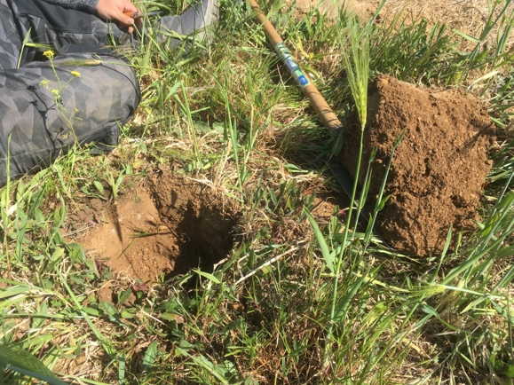 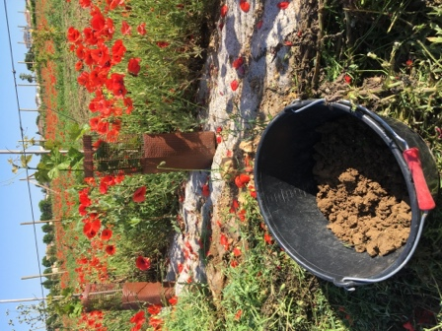

**Towards agroecological vineyards: how to measure and assess soil quality and fertility?**

**Supervision:** Raphaël METRAL raphael.metral@supagro.fr

**Keywords:** sustainable viticulture, soil indicators, soil fertility

**Context**

Viticulture is facing various issues that threaten its sustainability : soil degradation leading to fertility loss and erosion (Novara et al., 2018; Prosdocimi et al., 2016), pesticide use and their environmental impact (Fouillet et al., 2022), climate change and its consequences for water management (Mirás-Avalos and Araujo, 2021) and grapevine production in general (Naulleau et al., 2021; van Leeuwen et al., 2019). Soil management is of particular importance in vineyards: indeed, grapevine is often little fertilized and cultivated in moderate stress from flowering to harvest to favor fruit growth and berry quality instead of vegetative development (dos Santos et al., 2007; Pellegrino et al., 2006). Frequent weeding and soil tillage combined with low organic inputs often result in a degraded soil quality (Salomé et al., 2016). The adoption of agroecological practices is thus needed to answer these issues and increase viticulture sustainability.

Agroecological practices for soil management, such as service crops associated with no or very low soil tillage, aim to reduce soil erosion and to increase water infiltration, to improve soil physical properties (Polge de Combret - Champart et al., 2013), soil fertility (Christel et al., 2021), and carbon sequestration, to favor soil biodiversity and biological activity (Karimi et al., 2020). It help to regulate pests, natural enemies and weeds, so as the grapevine microclimate related to fungal diseases (Garcia et al., 2018; Winter et al., 2018).

**Objectives**

Within this project, you will investigate the assessment of the soil quality in vineyard. Your study will be based on an agroecological experimental grapevine plateform stand on the Chapitre estate (Villeneuve-les-Maguelone, Montpellier). Funded by the SALSA DEPHY EXPE project, this new experiment started in 2019. For this research, you will have (i) to define the assessment strategy for the soil quality evaluation and choose the relevant indicators, (ii) to measure some indicators on the experimental vineyard (if possible according to the time and financial constraints of your work), and (iii) to analyse, discuss the results (including the existing results since the beginning of the project) and make a proposal for the final assessment of the SALSA project.

**References**

Christel, A., Maron, P.-A., Ranjard, L., 2021. Impact of farming systems on soil ecological quality: a meta-analysis. Environ Chem Lett 19, 4603–4625. https://doi.org/10.1007/s10311-021-01302-y

dos Santos, T.P., Lopes, C.M., Lucília Rodrigues, M., de Souza, C.R., Ricardo-da-Silva, J.M., Maroco, J.P., Pereira, J.S., Manuela Chaves, M., 2007. Effects of deficit irrigation strategies on cluster microclimate for improving fruit composition of Moscatel field-grown grapevines. Scientia Horticulturae 112, 321–330. https://doi.org/10.1016/j.scienta.2007.01.006

Fouillet, E., Delière, L., Chartier, N., Munier-Jolain, N., Cortel, S., Rapidel, B., Merot, A., 2022. Reducing pesticide use in vineyards. Evidence from the analysis of the French DEPHY network. European Journal of Agronomy 136, 126503. https://doi.org/10.1016/j.eja.2022.126503

Garcia, L., Celette, F., Gary, C., Ripoche, A., Valdés-Gómez, H., Metay, A., 2018. Management of service crops for the provision of ecosystem services in vineyards: A review. Agriculture, Ecosystems & Environment 251, 158–170. https://doi.org/10.1016/j.agee.2017.09.030

Karimi, B., Cahurel, J.-Y., Gontier, L., Charlier, L., Chovelon, M., Mahé, H., Ranjard, L., 2020. A meta-analysis of the ecotoxicological impact of viticultural practices on soil biodiversity. Environmental Chemistry Letters 18, 1947–1966. https://doi.org/10.1007/s10311-020-01050-5

Mirás-Avalos, J.M., Araujo, E.S., 2021. Optimization of Vineyard Water Management: Challenges, Strategies, and Perspectives. Water 13, 746. https://doi.org/10.3390/w13060746

Naulleau, A., Gary, C., Prévot, L., Hossard, L., 2021. Evaluating Strategies for Adaptation to Climate Change in Grapevine Production–A Systematic Review. Front. Plant Sci. 11, 607859. https://doi.org/10.3389/fpls.2020.607859

Novara, A., Pisciotta, A., Minacapilli, M., Maltese, A., Capodici, F., Cerdà, A., Gristina, L., 2018. The impact of soil erosion on soil fertility and vine vigor. A multidisciplinary approach based on field, laboratory and remote sensing approaches. Science of The Total Environment 622–623, 474–480. https://doi.org/10.1016/j.scitotenv.2017.11.272

Pellegrino, A., Gozé, E., Lebon, Eric., Wery, J., 2006. A model-based diagnosis tool to evaluate the water stress experienced by grapevine in field sites. European Journal of Agronomy 25, 49–59. https://doi.org/10.1016/j.eja.2006.03.003

Polge de Combret - Champart, L., Guilpart, N., Mérot, A., Capillon, A., Gary, C., 2013. Determinants of the degradation of soil structure in vineyards with a view to conversion to organic farming. Soil Use Manage 29, 557–566. https://doi.org/10.1111/sum.12071

Prosdocimi, M., Cerdà, A., Tarolli, P., 2016. Soil water erosion on Mediterranean vineyards: A review. CATENA 141, 1–21. https://doi.org/10.1016/j.catena.2016.02.010

Salomé, C., Coll, P., Lardo, E., Metay, A., Villenave, C., Marsden, C., Blanchart, E., Hinsinger, P., Le Cadre, E., 2016. The soil quality concept as a framework to assess management practices in vulnerable agroecosystems: A case study in Mediterranean vineyards. Ecological Indicators 61, 456–465. https://doi.org/10.1016/j.ecolind.2015.09.047

van Leeuwen, Destrac-Irvine, Dubernet, Duchêne, Gowdy, Marguerit, Pieri, Parker, de Rességuier, Ollat, 2019. An Update on the Impact of Climate Change in Viticulture and Potential Adaptations. Agronomy 9, 514. https://doi.org/10.3390/agronomy9090514

Winter, S., Bauer, T., Strauss, P., Kratschmer, S., Paredes, D., Popescu, D., Landa, B., Guzmán, G., Gómez, J.A., Guernion, M., Zaller, J.G., Batáry, P., 2018. Effects of vegetation management intensity on biodiversity and ecosystem services in vineyards: A meta-analysis. Journal of Applied Ecology. https://doi.org/10.1111/1365-2664.13124